**GREEDY ALGORITHMS(TOP_20)**

1. **Minimum number of coins**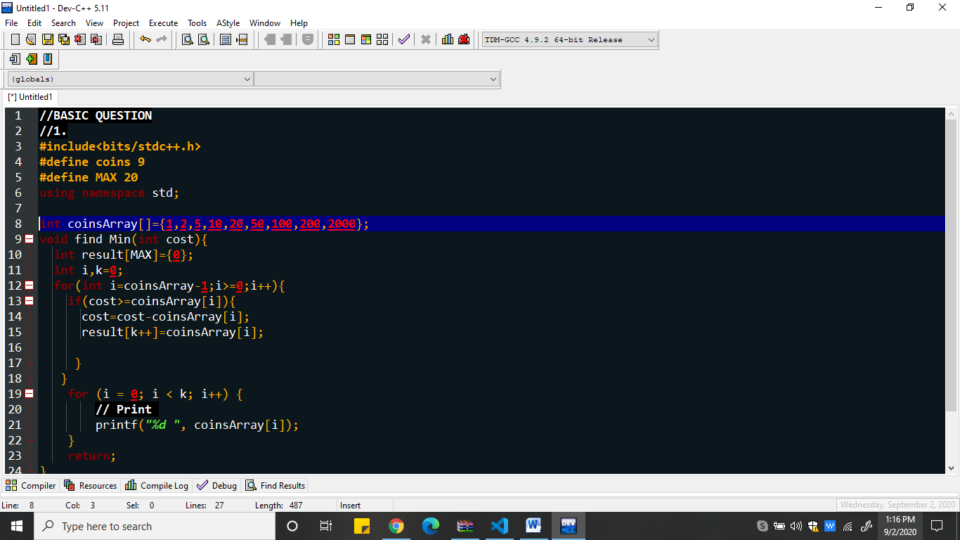
2. **Fractional Knapsack**

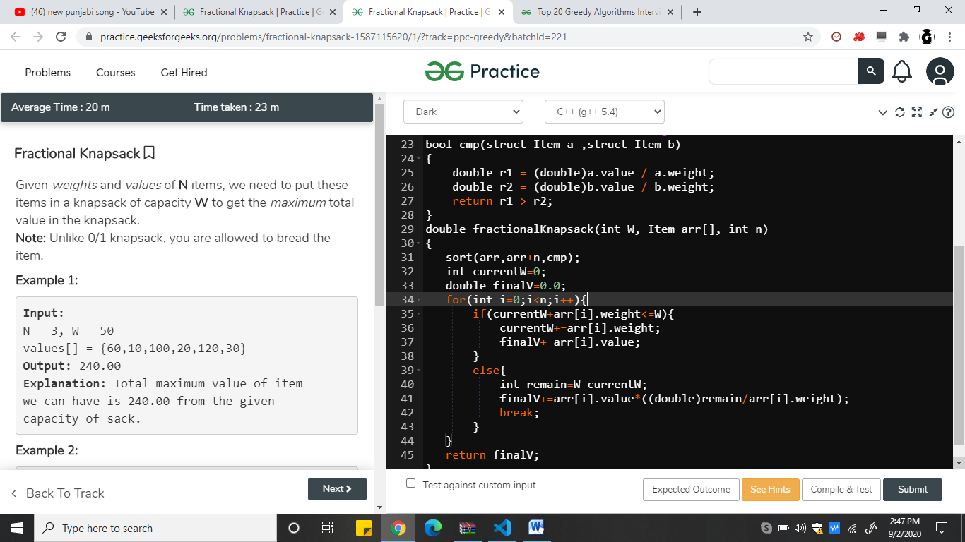

1. **Activity Selection Problem**

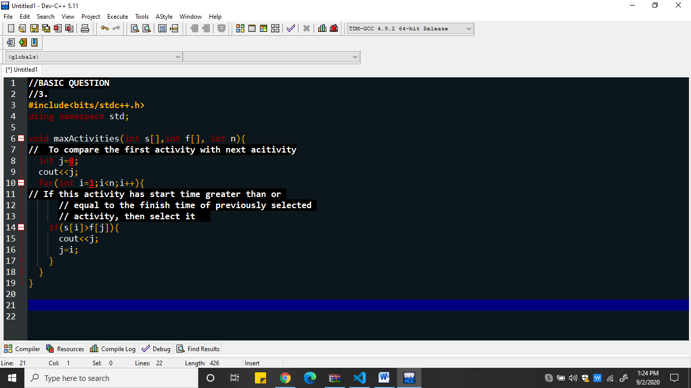

1. **Job sequencing Problem**

